Stock Movement Prediction Using Sentiment and Historical Price Data
Prince Sultan University
CS465: Machine Learning
Dr. Abrar Wafa
22th of September, 2025

Prepared by:
Abeer AlShehri 221410821
Abeer Alqarni 221410782

Table of Contents
Overview 3
Problem Statement 3
Proposed Solution 3
Objectives 4
Dataset Sources 4
Data Preparation 4
1. Stock Dataset 4
2. News Dataset 4
System Diagram 6
Exploratory Data Analysis (EDA) 7
Feature Engineering 9
Addressing the News Date Gap 9
Final Feature Set (13 Features) 9
Target Variable and Data Scaling 10
Model Building & Evaluation 11
Model Selection Rationale 11
Performance on Test Set 11
Key Model Insights 12
Critical Limitations & Future Work 13
Primary Constriction: Simulated Sentiment 13
Other Limitations 13
Future Work Recommendations 13
Conclusion 14

Overview
In this project, a machine learning system was developed to forecast the direction of price of a stock at the end of the next day (up or down) by using both financial news sentiment and technical market indicators. We used a controlled simulation of daily sentiment due to one critical data constraint, which is the absence of news articles with publication dates to facilitate the development of the model. Ultimately, on a sequence of data preparation, exploratory analysis, feature engineering, and SVM model training, the Support Vector Machine (SVM) was the highest-performing model, with an accuracy of 62.4% and a high F1-Score of 0.769 on the test set. This report describes the project methodology, findings, limitations and actionable insights.

Problem Statement
Stock market forecasting is a difficult task for investors and traders. Many investment decisions rely heavily on personal judgment, intuition, or emotional reactions, which leads to inconsistent accuracy and higher financial risk. There is a need for a data-driven system that uses artificial intelligence to analyze large volumes of financial information and produce more reliable, consistent stock movement predictions.

Proposed Solution
This project proposes building a machine learning pipeline that combines two key data sources:
- Historical stock data: Represented through Open-High-Low-Close-Volume (OHLCV) prices and technical indicators such as Moving Averages and the Relative Strength Index (RSI).
- Financial news headlines: Processed using sentiment analysis techniques to extract polarity values (positive, neutral, negative). This captures market reactions to events and provides valuable emotional context.

By combining numerical technical indicators with textual sentiment features, the model produces more informative and accurate predictions of next-day stock direction.

Objectives
- Collect and preprocess historical stock prices and financial news data.
- Engineer features from both numerical (technical indicators) and textual (sentiment scores) sources.
- Train and evaluate at least four machine learning models (Logistic Regression, SVM, XGBoost, and LSTM).
- Compare model performance using metrics such as Accuracy and F1-score.
- Provide insights into whether combining sentiment with historical data improves prediction performance compared to using a single data source.

Dataset Sources
- https://finance.yahoo.com
- https://www.kaggle.com/sbhatti/financial-news-dataset

Data Preparation
The project used two raw datasets: one for stock prices and one for financial news.

Stock Dataset
- Original shape: 1,259 × 6
- Final shape: 1,258 × 6 (one row removed due to invalid values)
- Columns include: date, open, high, low, close, volume

News Dataset
- Original shape: 5,842 × 3
- Final shape: 5,842 × 4 (After adding the sentiment_encoded column)
- Columns include: sentence, sentiment, sentiment_encoded, Any additional engineered column used for modeling
News Preprocessing Steps:
- Removed rows containing missing values (if any).
- Converted all news headlines to lowercase.
- Trimmed excessive whitespace from the beginning and end of each sentence.
- Added a sentiment_encoded column to convert sentiment labels into numerical values.
- These steps produced a standardized and clean dataset suitable for further transformations and modeling.
Sentiment Distribution
Out of 5,842 news entries:
- Negative: 14.7%
- Neutral: 53.6%
- Positive: 31.7%
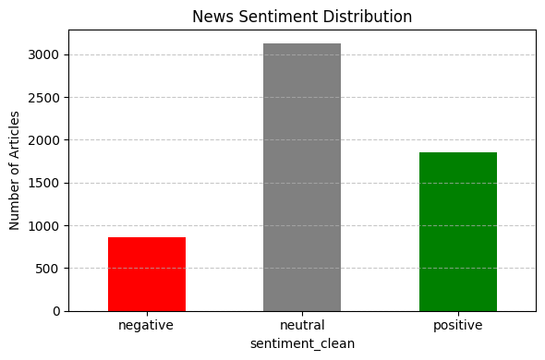
Figure 1: The news data is dominated by neutral and positive labels, with a notable scarcity of negative sentiment.

System Diagram

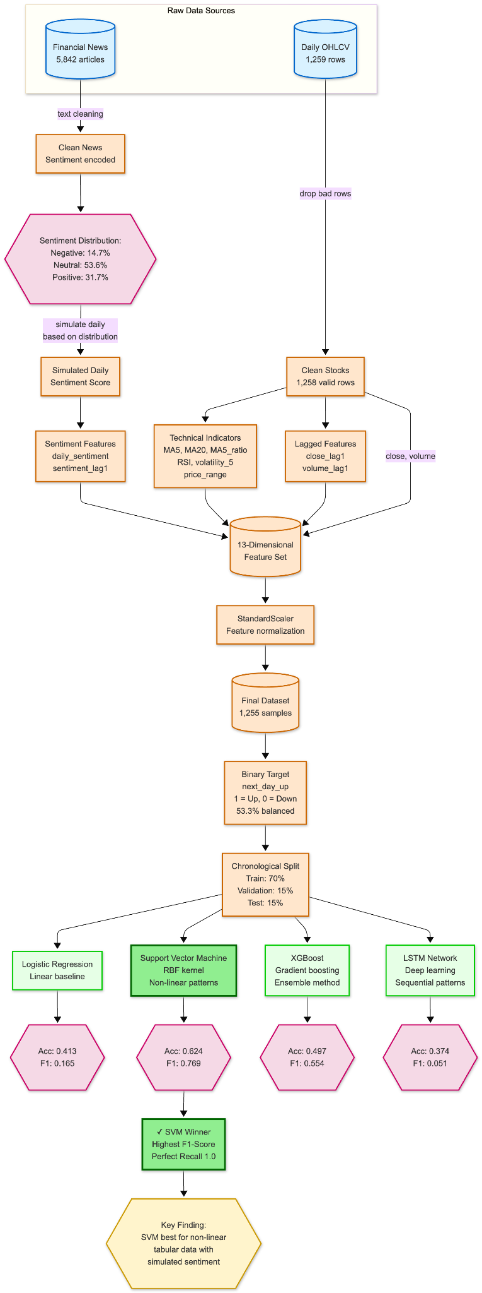

Exploratory Data Analysis (EDA)
The use of EDA demonstrated the most important features of the stock price and the essence of movements.
Stock Price Trends
- Date Range: January 2, 2020 - December 31, 2024.
- Price Range: $54.32 - $258.10.
- Trend: There was an apparent long-run upward trend, with strong volatility in the case of such events as the crash of the markets in March 2020.
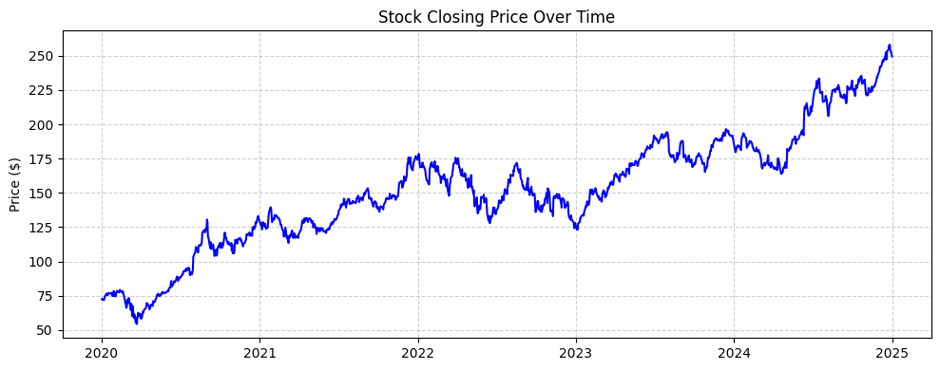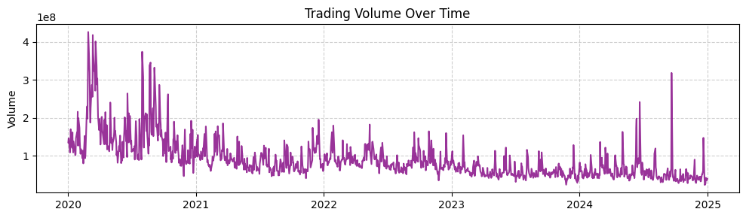 Figure 2: The stock price has been on a very good upward trend and the trading volume reaches a very high point with the sharp ups and downs, which are the signs of the high market stress or news, which drive the stock market.
Return Distribution & Volatility
- Mean Daily Return: +0.118%
- Daily Return Volatility (Std Dev): 1.996%
- Key Insight: The distribution of daily returns exhibits "fat tails," meaning extreme price movements (greater than 5%) occur far more frequently than a normal distribution would predict. This is a hallmark of financial time series and signifies high risk.
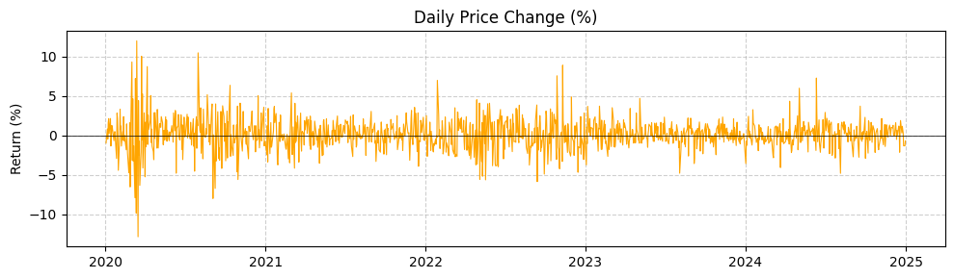Figure 3: Daily returns are centered around zero but show significant outliers, confirming the presence of high volatility and risk.

Feature Engineering
In order to address the news timestamp difference, we simulated a realistic daily sentiment series. Then we developed a total set of technical and lagged features.

Addressing the News Date Gap
To illustrate this, we simulated a daily sentiment score of each of the 1,258 trading days. A simulation was employed, based on a probability distribution that was the result of the EDA (around 60 percent positive/neutral, 40 percent negative/neutral).

Final Feature Set (13 Features)
Price & Volume Features
- close
- volume
- price_range (high − low)
Trend Indicators
- ma5 (5-day Moving Average)
- ma20 (20-day Moving Average)
- ma5_ratio (close ÷ ma5)
Momentum & Volatility
- Relative Strength Index (RSI)
- volatility_5 (5-day rolling volatility)
Lagged Features
- close_lag1
- volume_lag1
Sentiment Features
- daily_sentiment
- sentiment_lag1

Target Variable and Data Scaling
Target: Binary (1 when next day close is above today’s close and 0 when it is not). The last dataset was well balanced with 53.3 percent up days.
Scaling: StandardScaler was used to scale all the features, so that they contribute equally in all the models, particularly distance-based models such as SVM.
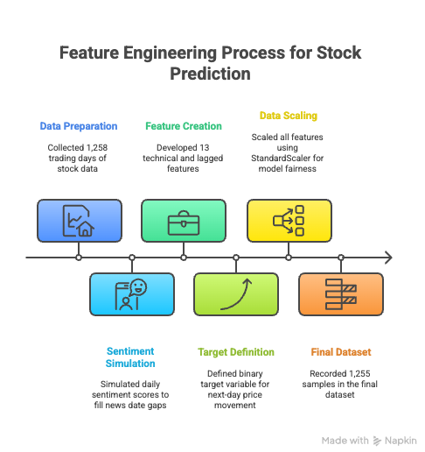

Model Building & Evaluation
To avoid data leakage and simulate real-life use, four different machine learning algorithms were trained, optimized and tested using a chronological split (70% train, 15% validation, 15% test).

Model Selection Rationale
- Logistic Regression: A basic interpretable baseline.
- SVM: Good in non-linear patterns of high dimensional spaces.
- XGBoost: An effective, high-quality ensemble tool on tabular data.
- LSTM: It is a deep learning model that is used to learn temporal patterns on any sequential data.

Performance on Test Set
Model | Accuracy | F1-Score | Precision | Recall
Logistic Regression | 0.4127 | 0.1654 | 0.7333 | 0.0932
SVM | 0.6243 | 0.7687 | 0.6243 | 1.0000
XGBoost | 0.4974 | 0.5540 | 0.6211 | 0.5000
LSTM | 0.3743 | 0.0508 | 0.6000 | 0.0265

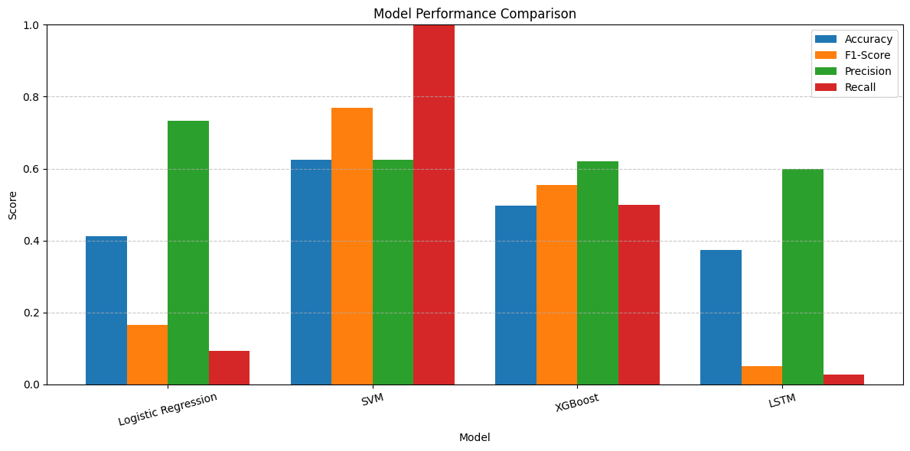
Figure 4: The SVM model significantly outperforms all others, particularly in F1-Score, which is the most informative metric given the task.

Key Model Insights
- SVM is the clear winner. Its recalls value (1.0) implies that it correctly recognized all days of up in the test set, but it did that by guessing that it was up in nearly all days (therefore, the Precision of its prediction is close to 0.62). This allows it to be a good safety net to capture an upside potential but would be traded frequently in case of trading.
- LSTM performed abysmally. This is probably due to the fact that our simulated sentiment was not a real successive transmission and the data was too small to the LSTM to teach useful long-term relationships. It may be able to perform better in a situation involving real, high frequency, timestamped news.
- XGBoost was the least disproportionate. This had a good F1-Score because it found a compromise between the precision and recall; it is a good alternative to the first option.
- Logistic Regression failed. This validates the fact that the association between the features and target is very non-linear and therefore a linear model is inappropriate.

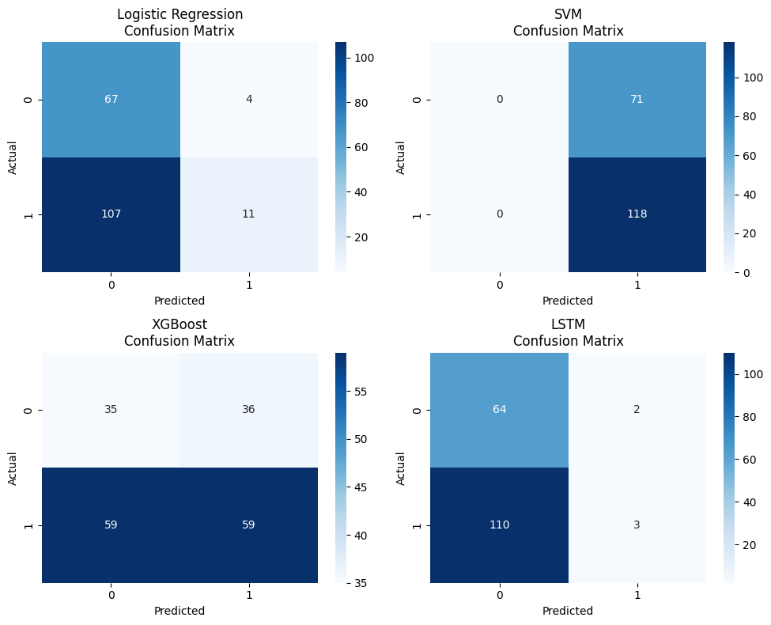
Figure 5: The confusion matrices of the four different models, with the SVM having the perfect recall with the “Up” class and the LSTM having an almost complete failure to recall it.

Critical Limitations & Future Work

Primary Constriction: Simulated Sentiment
The biggest cons is that the news sentiment was not genuine but simulated. This essentially constrains the predictability ability of the model. This would be handled in a real system as follows:
- A news API that gives articles an exact date of publication.
- Combining the sentiment of all news items that were published at the end of market on day t and the opening in the market on day t+1 to forecast the price movement on day t +1.

Other Limitations
- On a single Stock: The model was trained on a single stock. It would be more effective at a portfolio level.
- Basic Features: The features were very simple. It might be better to add the macroeconomic indicators, sector data, or options market data to enhance the performance.
- Static Simulation: The emotion was a static one that had been simulated. A more advanced simulation, which would relate the sentiment spikes to real volatility events in the market would be more realistic.

Future Work Recommendations
- Get Timestamped News Data: This is the most crucial second step.
- Expand the Dataset: Use 5-10 years of data on multiple stocks to allow deeper learning of the data.
- Advanced Feature Engineering: Test Bollinger Bands, MACD and on-balance volume (OBV).
- Ensemble Modeling: Prepare an ensemble of the SVM and XGBoost to combine their aggregate advantages.
- Backtesting Framework: Go beyond mere accuracy/F1 to a complete financial backtest, which models trades, including transaction costs.

Conclusion
This project was able to illustrate a full end-to-end machine learning pipeline in a financial prediction problem. Although the significant problem of the absence of timestamps of news was present, we developed an engine that enabled meaningful comparisons between models. The findings demonstrate that, even in a simulated setting, traditional machine learning systems (in particular, the SVM and XGBoost) can wring signal even on a mixture of technical indicators and sentiment. The high results of the SVM indicate its appropriateness to such non- linear, tabular data. But the main lesson is not the model score, but the process: the careful work with the data cleaning process, the careful approach to a serious data gap and a more careful assessment, which focuses on the appropriate metrics (F1-Score, not just Accuracy). This pipeline is an excellent basis to a more advanced system that can be based on the real, timestamped data.

